**Virtual HR**

**DAB-322 Capstone Project 1**

**Group 10**

**Amanpreet Kaur, Japneet Singh Kukreja, Vaidehi Devani**

**Introduction**

In this era of technology, individuals are dependent on machine which can make their life easy. Specially, in the IT sector we are using more n more software to ease our work. Industries are looking for a candidate who has enough knowledge and skills to build unique software or system which help them to save time. It’s all started with hiring process (interview). Now, almost all the company check resume in software, they short out the resume with few keywords, years of experience in the field and many more important factors which is needed for the role. By looking on that I get an idea to conduct the interview online and predict the result based on confidence level and relevant answers. We can conduct the first round of the interview which is question about personal information, year of work experience, question related to job role and responsibilities. Right now, company has a person who is conducting this round but by considering the time it is consuming and rush of job application. They are not able to respond all the candidate on time and candidate must wait for the interview round then they have to wait for the first-round result, it is time consuming process.

Our project definition “INTERVIEW RESULT PREDICTION BY USING ALEXA” is particularly an Amazon device named Alexa through which we can conduct interview in a quick-witted way.Nowadays, Smart devices are in a great demand and the audience is also becoming smarter day by day. Hence, our team has also thought smartly to conduct interview with help of Alexa and predicting expression to check the confidence level. Alexa needs to be voice up by the interviewee to start the interview. Interview will be in one-to-one manner, and it will be taken personally. This smart interview conduction will reduce the HR load and also becomes easy to manage the list of interviews occurred. This system would provide better data and also maintain the list of skills interviewee possesses. We would conduct the interview by placing AI program named Alexa. Alexa communicates with the candidate of interview and ask the questions whose answers can be analysed in brief. This device focuses to generate questions according to the qualification and the post he/she is applying and notify him/her for the next round. As well as we can train machine learning model which will take the photos of the candidate every 10second and at the end of the interview it will check the confidence level of the candidate and on the other hand we do the speech recognition, we will compare the candidate answers with our expected answers which is already in the system. Model will only compare those answers with candidate answers. By considering all at the end it will show the result that is the candidate eligible for the next round or not?

It will save the time of employee who is conducting the interview. He/She must take care of the data only like, which candidate passed the auto interview round and eligible for the technical round and set their technical interview.

**Motivation**

**1. Convenience:** When the interviewer and the interviewee are in dissimilar places, doing in-person interviews can be time-consuming and inconvenient. By removing the need for actual travel, a virtual interview machine may save time and money.

**2. Efficiency:** By streamlining the interview process, a virtual interview machine can improve its effectiveness and consistency. The likelihood of prejudice or discrimination can be decreased by programming the machine to ask the identical set of questions to every applicant.

**3. Cost-effective:** Doing interviews in-person may be costly, especially if the organization is responsible for the interviewee's travel and lodging expenses. The price of conducting interviews may be greatly decreased using a virtual interview machine.

**4. Scalability:** The interview process can be scaled up to accommodate a large number of candidates at once using a virtual interview machine. This can be especially helpful for businesses that receive a lot of applications for jobs.

**5.** **Standardization:** By ensuring that each candidate is evaluated in accordance with the same set of criteria, a virtual interview machine can assist in standardizing the interview process. The selection process may be fairer and taking emotions out from the process.

In general, the goal of developing a virtual interview machine is to make the interviewing process easier, more effective, and more objective for both the interviewer and the interviewee.

**Solution Outline:**

Provide a virtual interviewing tool that can analyze candidates' credentials and suitability for the position while conducting online job interviews. In addition to simulating a face-to-face interview, the system should use AI and machine learning to examine the applicant's replies, actions, and facial expressions.

The system will be judged on its accuracy in determining a candidate's suitability for the position, convenience of use, and capacity to offer interviewers insightful information and suggestions.

Some Features: -

1. Provide a platform for organizing and carrying out video interviews with applicants.

2. Employ machine learning techniques and natural language processing (NLP) to examine the applicant's answers to interview questions.

4. Provide the interviewer a report that includes suggestions and a summary of the candidate's performance.

5. Provide an easy-to-use interface and detailed instructions that are understandable to both interviewers and candidates.

**Libraries:**

Computer Vision is a field that attempts to enable computers to understand and interpret visual information from the outside world in the same way as humans perceive and understand visual data. It draws on a variety of disciplines, including computer science, mathematics, image processing, machine learning, and artificial intelligence, to create methods and strategies for analyzing and understanding visual input.

**OpenCV** is a complete computer vision library that includes image processing, object detection, feature extraction, image stitching, and other features. Because of its vast capabilities and ease of use, it is frequently utilized in both academia and industry for building computer vision applications.

**Python:**

Python is an actively computationally translated, object-oriented programming language. Python makes use of an incredibly useful language and makes it simple to use. Python has a very convenient language that makes it easy to use. Because of its simplicity, versatility, and extensive ecosystem of libraries, Python has emerged as the standard programming language for many AI-related tasks, including computer vision. Because of its broad Python support, OpenCV is a popular choice for developers working on computer vision projects.

**NumPy:**

NumPy is a strong Python numerical computing package that offers efficient array operations and mathematical algorithms. It is frequently used with OpenCV to handle and process images and other visual data. NumPy's array operations enable rapid and efficient computation on big datasets, making it an excellent candidate for picture data handling in computer vision applications.

**pyttsx3**:

Pyttsx3 is a Python library for Text-to-Speech (TTS) conversion. It provides a way to convert written text into spoken words using different voices and audio output devices.

Pyttsx3 provides a simple interface to convert text to speech. It has support for multiple languages, including English, French, German, and Spanish. It also allows you to set voice properties such as voice type, volume, and rate of speech.

The library can be used in a variety of applications, such as text readers, navigation systems, and language learning software. It is also useful in applications where you need to provide audio feedback to users, such as in accessibility applications for visually impaired users.

Pyttsx3 is easy to install and use, making it a popular choice for Python developers who need to implement TTS in their projects.

The combination of OpenCV, Python, and NumPy creates a stable and adaptable framework for developing computer vision applications. It enables developers to combine the capabilities of OpenCV's computer vision algorithms with the ease of Python programming and the efficient array operations of NumPy, making it a popular choice for computer vision researchers, developers, and practitioners.

**Speech Recognition:**

Speech Recognition is a Python library that allows developers to easily integrate speech recognition capabilities into their applications. It supports several speech recognition engines, including Google Speech Recognition, Google Cloud Speech API, Microsoft Bing Voice Recognition, IBM Speech to Text, and many more.

With Speech Recognition, developers can capture audio from various sources, including microphones, audio files, and streaming audio. Once the audio is captured, the library can convert it to text using the specified speech recognition engine.

Speech Recognition also provides a range of features such as setting the duration of the audio input, adjusting the energy threshold, and detecting non-speech audio, among others.

The library is easy to use and provides developers with an efficient and effective way to add speech recognition capabilities to their Python applications.

**Objective**

The creation of a more effective, objective, and efficient interview process that is beneficial to both the employer and the candidates is the goal of a virtual interviewing system.

As the number of smart gadgets and technologies increases daily, we must continue to study and develop new products for the public. The major goal is to use Alexa to conduct interviews without any human involvement. This will lead to increased resource use that is wisely allocated. Additionally, we will begin to learn about the new technology, and jobs will increase.

**Major objectives: -** Improving efficiency, reducing biasness, increasing accuracy and consistency, and facilitating remote hiring.

**Literature Survey comparison**

1. [**https://www.cnbc.com/2019/02/28/resume-how-yours-can-beat-the-applicant-tracking-system.html#:~:text=beats%20the%20bots-,75%25%20of%20resumes%20are%20never%20read%20by%20a%20human%E2%80%94here's,your%20resume%20beats%20the%20bots&text=Job%20seekers%2C%20forget%20recruiters%20and,you%20need%20to%20please%20first**](https://www.cnbc.com/2019/02/28/resume-how-yours-can-beat-the-applicant-tracking-system.html#:~:text=beats%20the%20bots-,75%25%20of%20resumes%20are%20never%20read%20by%20a%20human%E2%80%94here's,your%20resume%20beats%20the%20bots&text=Job%20seekers%2C%20forget%20recruiters%20and,you%20need%20to%20please%20first)

**Summary:** The article from CNBC discusses how applicant tracking systems (ATS) are used by companies to filter through the large volume of resumes they receive and how job seekers can optimize their resumes to beat the ATS and get noticed by hiring managers. The article highlights that 75% of resumes are never read by a human, but are instead screened by ATS, which use algorithms to scan resumes for specific keywords and qualifications. The article also recommends that job seekers avoid using graphics, tables, and other formatting elements that can confuse the ATS and instead use simple, easy-to-read formats.

Overall, the article highlights the importance of optimizing resumes for ATS in order to increase the chances of getting noticed by hiring managers. However, it is also important for job seekers to ensure that their resumes accurately represent their skills and experience, and not just focus on pleasing the algorithm.

1. [**https://www.linkedin.com/pulse/what-happens-your-resume-after-you-apply-erik-topper/**](https://www.linkedin.com/pulse/what-happens-your-resume-after-you-apply-erik-topper/)

**Summary:** The article on LinkedIn titled "What Happens to Your Resume After You Apply" by Erik Topper explores the process that takes place after a job seeker applies for a position and submits their resume. The article describes how resumes are often first reviewed by an applicant tracking system (ATS), which scans the resume for keywords and qualifications that match the job description. The article notes that resumes are typically reviewed in a matter of seconds, so it is important for job seekers to make sure their resumes are clear and easy to read, with relevant experience and accomplishments highlighted prominently.

Overall, the article provides valuable insights into the post-application process and highlights the importance of tailoring resumes to match job descriptions and being prepared for potential follow-up interactions with the employer.

1. [**https://www.indeed.com/career-advice/finding-a-job/what-happens-to-my-resume-after-i-apply**](https://www.indeed.com/career-advice/finding-a-job/what-happens-to-my-resume-after-i-apply)

**Summary:** The article notes that after a job seeker applies for a job, their resume is first reviewed by an applicant tracking system (ATS) to determine if they meet the minimum qualifications for the position. The article emphasizes the importance of tailoring the resume to the job description and ensuring that it clearly highlights the relevant skills and experiences. The article also highlights that job seekers should be prepared for potential follow-up communications from the employer, such as requests for additional information or interviews. It is important for job seekers to monitor their email and phone for these communications and to respond in a timely and professional manner.

Overall, the article provides a useful overview of the process that a job seeker's resume undergoes after they apply for a job, emphasizing the importance of tailoring the resume and being responsive to potential employer communications.

1. [**https://www.instagram.com/reel/CpaI973oc30/?igshid=MDJmNzVkMjY%3D**](https://www.instagram.com/reel/CpaI973oc30/?igshid=MDJmNzVkMjY%3D)

Google Interview warmup refers to the process of preparing for an upcoming interview by practicing responses to common interview questions, researching the company and the position, and identifying key strengths and experiences to highlight during the interview. The goal of interview warmup is to feel more confident and prepared going into the interview and to improve the likelihood of a successful outcome.

On the other hand, our project Interview Result Prediction by using Alexa refers to the use of voice assistant technology to analyze and predict the outcome of an interview based on factors such as tone of voice, word choice, and facial expressions. This technology uses artificial intelligence and machine learning algorithms to analyze the data and generate a prediction of whether the interviewee is likely to be offered the job or not.

In summary, the best approach depends on the specific needs and preferences of the interviewee and the employer. A combination of interview warmup and technology-based evaluation may be the most effective way to prepare for an interview and make informed hiring decisions.

**References**

[**https://www.simplilearn.com/artificial-intelligence-ai-interview-questions-and-answers-article**](https://www.simplilearn.com/artificial-intelligence-ai-interview-questions-and-answers-article)

1. **The Current State of AI Adoption (Adoption of AI in the United States):**

Important differences in AI adoption also exist irrespective of a firm’s size First, firms in industries like information, professional services, management, and finance are the most likely to adopt AI technology. But workers in industries like retail trade, transportation, and utilities are also more likely to be exposed to AI than average. Second, irrespective of a firm’s size, younger firms are more likely to adopt AI. For example, of all large firms in the 95th to 99th

percentiles of the firm size distribution, roughly 7 percent of firms in the youngest age quartile have adopted AI, whereas only about 3 to 4 percent of firms in oldest age quartile have done so. The fact that AI adoption is concentrated in larger and younger firms most likely reflects the fact that adopting this technology entails substantial costs and organizational barriers. Further, firms with venture-capital funding and other characteristics McElheran et al. (2022) categorize as “startup conditions consistent with high-growth entrepreneurship” are correlated with the use of AI.

**References**: <https://www.whitehouse.gov/wp-content/uploads/2022/12/TTC-EC-CEA-AI-Report-12052022-1.pdf>

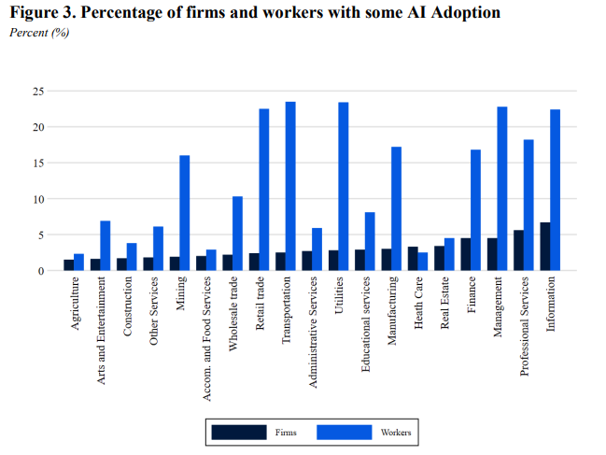

**Recent Progress on AI:**

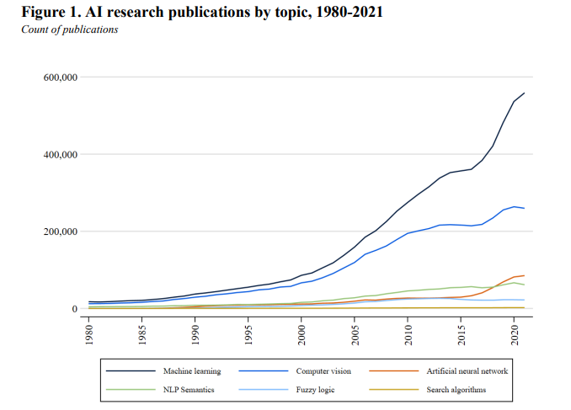

1. Distribution of Ratings for Alexa:

By looking at the pie chart above, we can conclude that most of the ratings are positive for Alexa. 72.6% customers have given Alexa a 5-star rating and 14.4% customers have given Alexa a 4-star rating. That means that 87% of the total customers have given Alexa at least a good rating. 4.83% of customers have given Alexa a 3-star rating. 3.05% of customers appear to not like Alexa as much as the other customers and chose to give only a 2-star rating to Alexa, whereas 5.11% people did not like Alexa and decided to give only 1-star rating. This feedback shows a total of 8.16% of the customers were not satisfied with Alexa. Overall, the ratings feedback is very positive, showing almost 90% of the customers being satisfied with the product.

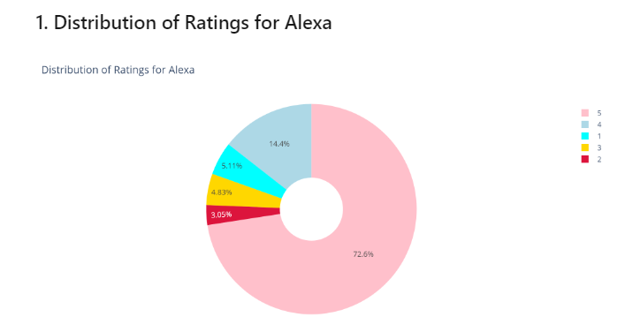

**References:** [**https://www.linkedin.com/pulse/what-i-learned-analyzing-over-three-thousand-amazon-alexa-gustineli/**](https://www.linkedin.com/pulse/what-i-learned-analyzing-over-three-thousand-amazon-alexa-gustineli/)

**Ethical 5 C's**

The "Interview Result Prediction by Using Alexa" project can be connected with the ethical 5 C's in the following ways:

**Consent:** To respect the principle of consent, the project should obtain informed consent from all stakeholders involved, including candidates and interviewers, before collecting any data or using Alexa to predict interview results. This can involve explaining the purpose of the project, what data will be collected, and how it will be used.

**Clarity:** The project should strive for clarity in its communication with stakeholders, ensuring that everyone involved understands the purpose of the project, the data being collected, and how it will be used. This can involve using clear and simple language, avoiding technical, and providing examples to help stakeholders understand the implications of the project.

**Consistency:** To be consistent, the project should ensure that all stakeholders are treated fairly and equitably. This can involve using consistent criteria to evaluate candidates, ensuring that interviewers are consistent in their evaluation of candidates, and avoiding biases that can result in inconsistent outcomes.

**Control:** To respect the principle of control, candidates should have control over their data and how it is used. This can involve giving candidates the ability to opt-in or opt-out of having their data used for the project, and providing them with transparency about how their data will be used. In addition, the project should be transparent about its methods and criteria for evaluating candidates, so that stakeholders understand how the outcomes are being generated.

**Consequences:** The project should take into account the potential consequences of its actions and strive to minimize harm to stakeholders. This can involve considering the potential impact of the project on candidates, interviewers, and the broader society, and taking steps to mitigate any potential harm that may result. For example, the project may choose to use the results of the interview prediction to supplement human judgment rather than replace it entirely, in order to avoid any harm that may result from relying solely on technology.

**conclusion**

In conclusion, Interview Result Prediction by Using Alexa is a potentially groundbreaking project that has significant implications for the HR and recruitment industry. The project involves designing, developing, and implementing a system that uses Alexa technology to analyze and predict the outcome of an interview. The system would need to collect data from the interviewee, analyze it using machine learning algorithms, and provide a prediction of the interview outcome.

The project scope includes several key components such as data collection, system architecture, user interface, machine learning algorithms, integration with Alexa, security and privacy, and testing and validation. The success of the project would depend on various factors such as technological advancements, user adoption, and business requirements.

The future scope of the project is potentially vast and could lead to significant advances in the field of HR and recruitment. This includes refinement and optimization of machine learning algorithms, integration with other systems and platforms, expansion to other industries, incorporation of additional data sources, use of advanced analytics techniques, and addressing potential ethical issues.

Overall, the Interview Result Prediction by Using Alexa project has the potential to revolutionize the way we conduct interviews and make hiring decisions. It is an exciting and challenging project that would require a team of experienced developers, data scientists, and AI experts to ensure its success.